Plotters

Plotters are a special type of output device. It is suitable for applications:

1. Architectural plan of the building.
2. CAD applications like the design of mechanical components of aircraft.
3. Many engineering applications.

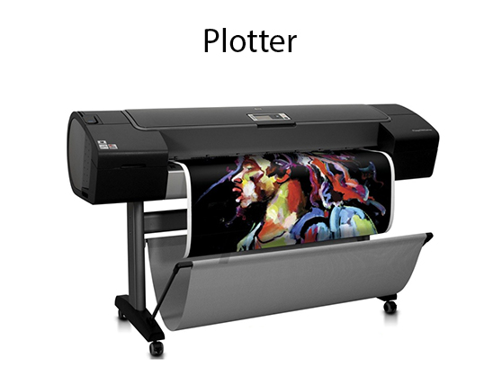

Advantage:

1. It can produce high-quality output on large sheets.
2. It is used to provide the high precision drawing.
3. It can produce graphics of various sizes.
4. The speed of producing output is high.

Drum Plotter:

It consists of a drum. Paper on which design is made is kept on the drum. The drum can rotate in both directions. Plotters comprised of one or more pen and penholders. The holders are mounted perpendicular to drum surface. The pens are kept in the holder, which can move left to the right as well as right to the left. The graph plotting program controls the movement of pen and drum.

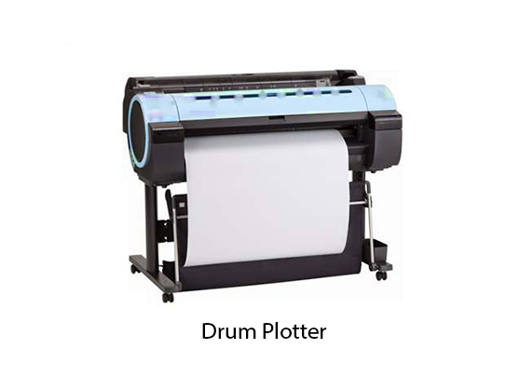

Flatbed Plotter:

It is used to draw complex design and graphs, charts. The Flatbed plotter can be kept over the table. The plotter consists of pen and holder. The pen can draw characters of various sizes. There can be one or more pens and pen holding mechanism. Each pen has ink of different color. Different colors help to produce multicolor design of document. The area of plotting is also variable. It can vary A4 to 21'*52'.

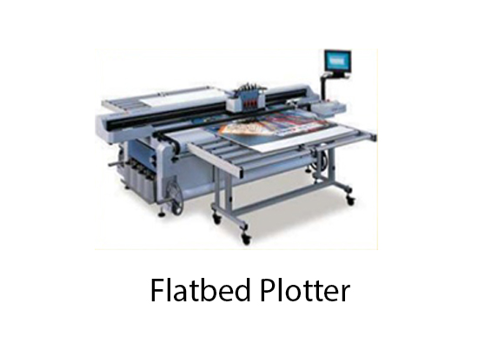

It is used to draw

1. Cars
2. Ships
3. Airplanes
4. Shoe and dress designing
5. Road and highway design

Graphics Software:

There are two types of Graphics Software.

**1. General Purpose Packages:** Basic Functions in a general package include those for generating picture components (straight lines, polygons, circles and other figures), setting color and intensity values, selecting views, and applying transformations.

Example of general purpose package is the GL (Graphics Library), GKS, PHIGS, PHIGS+ etc.

**2. Special Purpose Packages:** These packages are designed for non programmers, so that these users can use the graphics packages, without knowing the inner details.

Example of special purpose package is

1. Painting programs
2. Package used for business purpose
3. Package used for medical systems.
4. CAD packages